- Policy
  - Any person working off this protocol has previously received training on this specific piece of equipment by the RESTORE Lab Manager (Marisa Bickel) or Technical Director (David Gravano) with explicit instruction for independent equipment usage. Any persons operating equipment without prior training and/or permission will be removed from the facility immediately.
  - No food or drink within any of the RESTORE facility.
- Purpose
  - The purpose of this procedure establishes standardized requirements for the safe and proper operation of CryoStar NX50 Cryostat to ensure data quality, user safety, instrument integrity, and regulatory compliance.
- Responsibilities
  - The equipment operator is responsible for the proper handling, care, and oversight of all samples, animals, and associated materials while they are under the operator’s control during use of the instrument.
  - Users must follow safety procedures and log usage.
  - Report issues immediately to the lab manager.
- Procedure
  - Startup
    - Ensure chamber is clean and window closed.
A
B
C
Figure 4.2: Blade Installation
D
    - Equipment should be in standby, allow cryochamber and tools to reach operating temperature.

  - Blade Installation
Microtome blades are extremely sharp and can cause severe injuries – always use good laboratory practice when handling them. Always cover the blade with the blade/knife guard and activate then brake prior to making any adjustments to the blade/knife and specimen or changing the specimen.
    - Engage handwheel brake.
    - Use the front handle to move the anti-roll plate to the side. (Figure 4.2A)
    - Pull the blade clamping lever towards the front of the instrument to release the clamping plate. (Figure 4.2B)
    - Carefully slide a low profile blade into the middle of the slot, ensuring that the blade is equidistant from the ends of the slot. (Figure 4.2C)
    - Push the blade clamping lever towards the back of the instrument to clamp the blade in position. (Figure 4.3D) and reposition roll plate.

A
B
C
Figure 4.3: Blade Positioning
  - Blade Positioning
Always cover the blade with the knife/blade guard and activate the brake prior to making any adjustments to the assembly. If the cutting area of the blade is no longer usable, the upper part of the blade holder can be moved without removing the blade. To move the upper part of the blade holder:
    - Loosen the lateral adjustment lever. (Figure 4.3A)
    - The Upper part of the blade holder should now be free to move left and right.
    - Move it either to the left or to the right until the desired area of the blade is directly below the specimen head. (Figure 4.3B)
    - Move the lateral adjustment lever forward to secure the upper part of the blade holder in the new position. (Figure 4.3C)

  - Specimen Setup
    - Loosen the specimen chuck release lever and insert the specimen chuck into the jaws of the specimen head. (Figure 4.4A)
    - Push down on the specimen chuck release lever again to allow the jaws to grip the chuck.
    - Loosen the specimen head clamping lever to allow adjustment of the specimen parallel to the cutting edge. (Figure 4.4B)
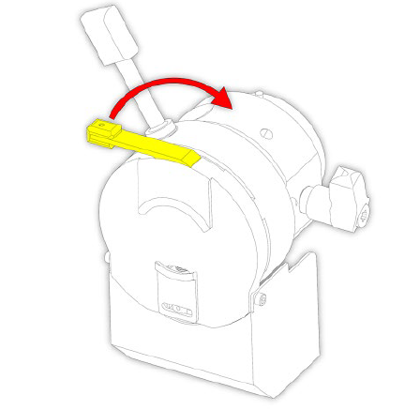
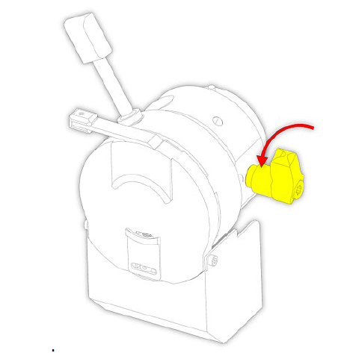
    - Use the orientation handle to orient the specimen on the x- and y-axes. (Figure 4.4C)
A
B
C
Figure 4.4: Specimen Setup
D
    - Tighten the specimen head clamping lever again. (Figure 4.4D)

  - Sectioning
    - Set trimming thickness (e.g., 10–30 µm).
    - Trim block to expose tissue.
    - Set fine section thickness (e.g., 5–10 µm).
    - Release handwheel brake.
    - Section using smooth, controlled motion.
    - Collect sections with cold brush or forceps.

  - Removing Used Blades with the Magnetic Blade Tool
A
B
C
Figure 4.6: Removing Used Blades with the Magnetic Blade Tool

The magnetic blade tool allows the user to remove used blades from the blade holder in a safe way. Remove the used blade with the magnetic blade tool:
    - Use the front handle to move the anti-roll plate to the side (Figure 4.6A)
    - Pull the blade clamping lever towards the front of the instrument to release the clamping plate. (Figure 4.6B)
    - Move the magnetic blade tool over the blade. Carefully lift the blade out of the blade holder and dispose of it in accordance with laboratory regulations. (Figure 4.6C)

  - Shutdown
    - Remove specimen and dispose per biohazard protocol.
    - Remove blade using magnetic tool → discard in sharps container.
    - Clean chamber of debris and frost.
    - Open window to allow moisture evaporation.
    - Put Instrument in standby.
    - Inspect for frost buildup
    - Wipe chamber with approved disinfectant (70% ethanol) when cryochamber at room temp.
    - Fill out the logbook.

- References
  - Please refer to the manual of the Epredia Cryostar NX50 (On the RESTORE website)

- Troubleshooting
Issue | Possible Cause | Action
Tissue crumbles | Too cold | Increase temperature
Tissue smears | Too warm | Decrease temperature
Sections curl | Anti-roll plate misaligned | Adjust plate
No cooling | Power/compressor issue | Contact lab manager

